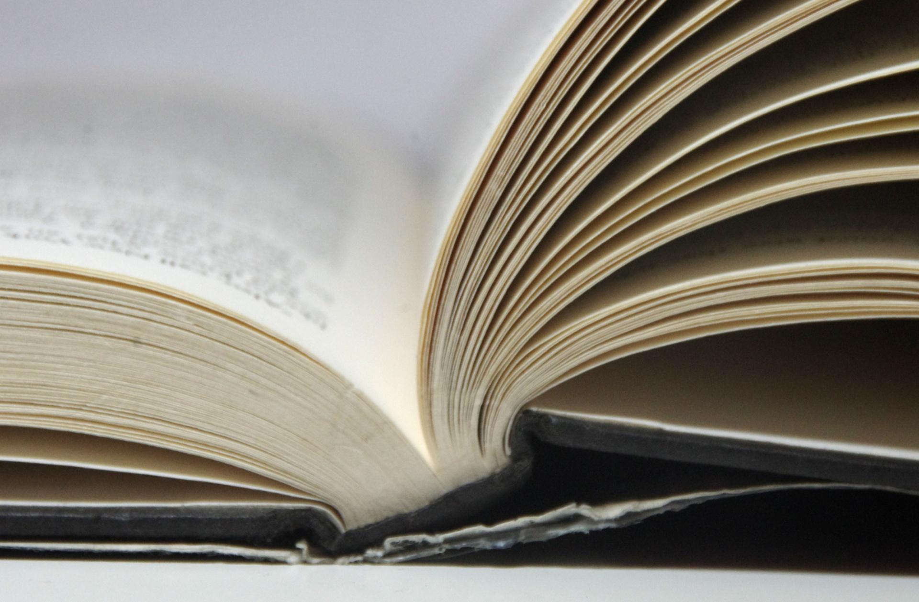
Summer Reading 2020 in English

Grade 7 -  עולים לכיתה ח | book / worksheets | link
Algrisi א | “All summer in a day” by Ray Bradbury | Google classroom  Drive Folder( for new students only)
Mazor ב | Donkey Skin (folktale) | Drive Folder( a story and questions)  Google classroom
Serpik ב | “How Suan Became Rich” | Google classroom  Drive Folder( a story and questions)

Grade 8-  עולים לכיתה ט | book/ worksheets | link
Sedova א | The Last Leaf - O’Henry  (Original version) | Google classroom  Drive folder for new students
Algrisi ב | 2BR02B by Kurt Vonnegut  ( pre-intermediate level) | google classroom  Drive Folder ( for new students only)
Mazor ג | The Last Leaf - O’Henry | Google classroom
Borisov | Newspaper Chase | Google classroom  Assignment  Book

Grade 9  עולים לכיתה י | book/ worksheets | link
Sedova ב | The Celebrated Jumping Frog – Mark Twain (original version) | Google Classroom  Drive Folder (only for new students)
Algrisi א | 2BR02B by Kurt Vonnegut  ( original version) | google classroom  Drive Folder ( for new students only )
Mazor ג | The Book of Sand  ( pre-intermediate level) | Dive Folder( a story, Book report)
Borisov א | Time Machine | Google classroom  Book  Assignment
Serpik ג- | Stargate (Pre-intermediate level) | Google classroom  Drive folder (Story, book report)

Grade 10  עולים לכיתה י | book/ worksheets | link
Sedova 5 points | The Last Question (Issak Asimov) | Edmodo  Drive Folder (for new students)
Algrisi 5 points | The Verger ( original) | Drive Folder ( for new students only)  Edmodo
Serpik 4 points | The Godfather (Intermediate level) | A story (text)
Borisov 4 points | A Good Boy (level 4) | Google classroom  Book  Assignment
Taashur Raviv  4 points | Book report  Instructions (Available Docs and Google classroom) | https://app.luminpdf.com/viewer/5ef25cfbc1a9b20012c54604

